# **Assignment 2 Questions**

1. **Change your password to a password you would like to use for the remainder of the semester.**

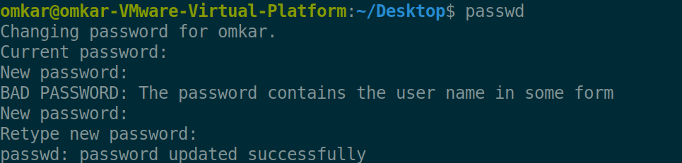

1. **Display the system’s date.**



1. **Count the number of lines in the /etc/passwd file.**



1. **Find out who else is on the system.**

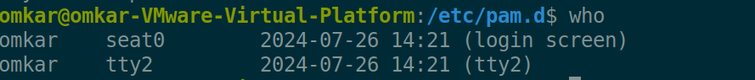

1. **Direct the output of the man pages for the date command to a file named *mydate*.**

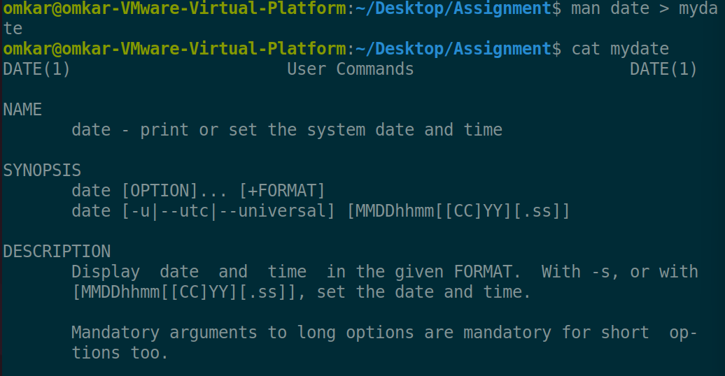

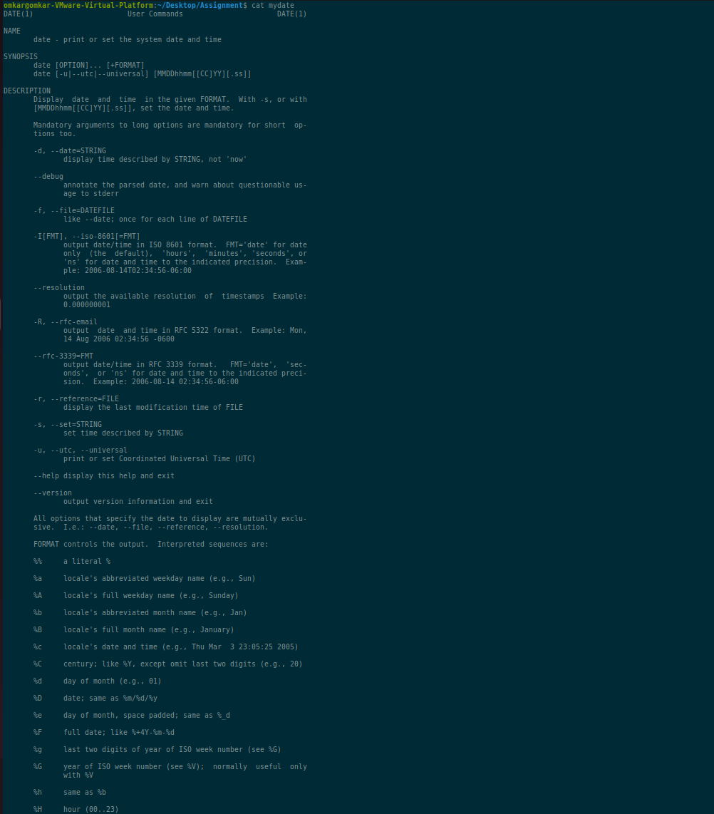 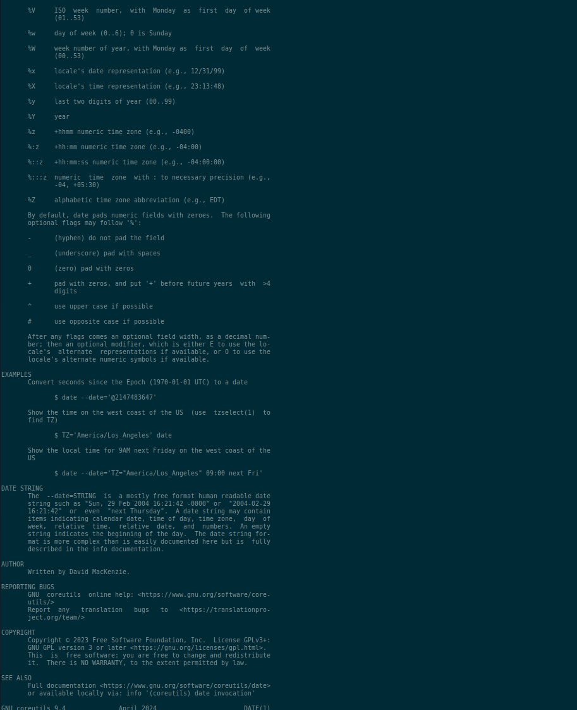

1. **Create a subdirectory called *mydir*.**

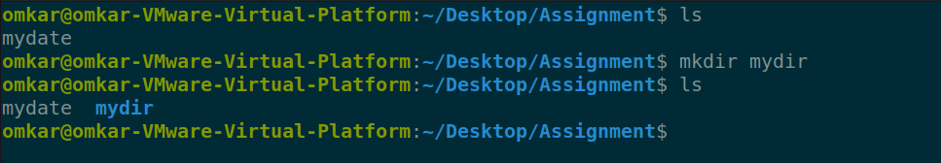

1. **Move the file *mydate* into the new subdirectory.**

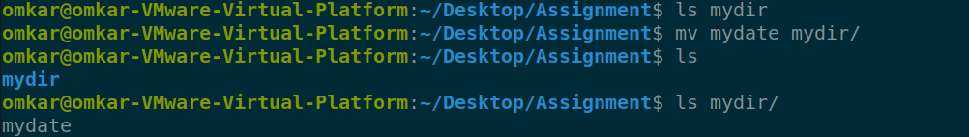

1. **Go to the subdirectory *mydir* and copy the file *mydate* to a new file called *ourdate***

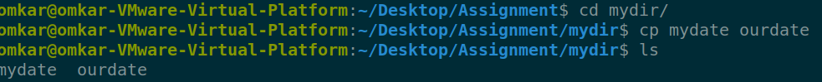

1. **List the contents of *mydir*.**



1. **Do a long listing on the file *ourdate* and note the permissions.**



**Permissions : user => RW | group=> RW | others=> R**

1. **Display the name of the current directory starting from the root.**



1. **Move the files in the directory *mydir* back to the HOME directory.**

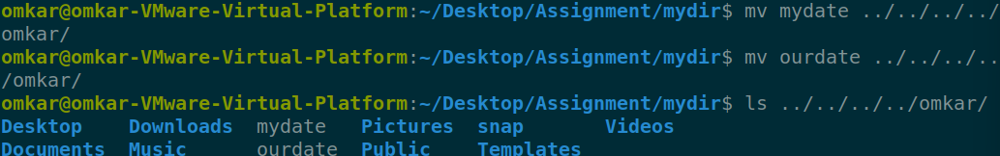

1. **List all the files in your HOME directory.**

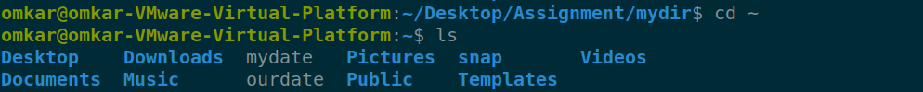

1. **Display the first 5 lines of *mydate*.**

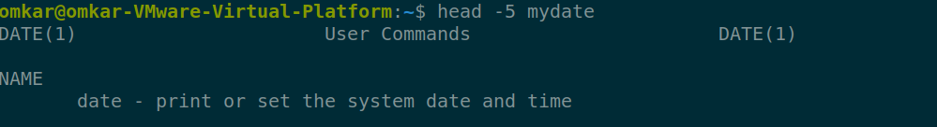

1. **Display the last 8 lines of *mydate*.**

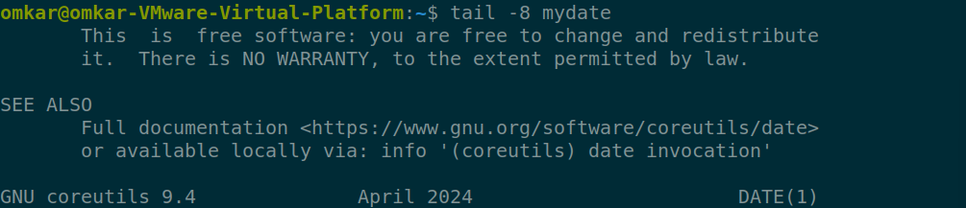

1. **Remove the directory *mydir*.**

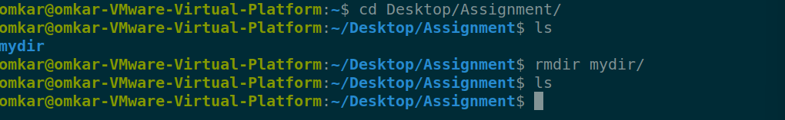

1. **Redirect the output of the long listing of files to a file named *list*.**

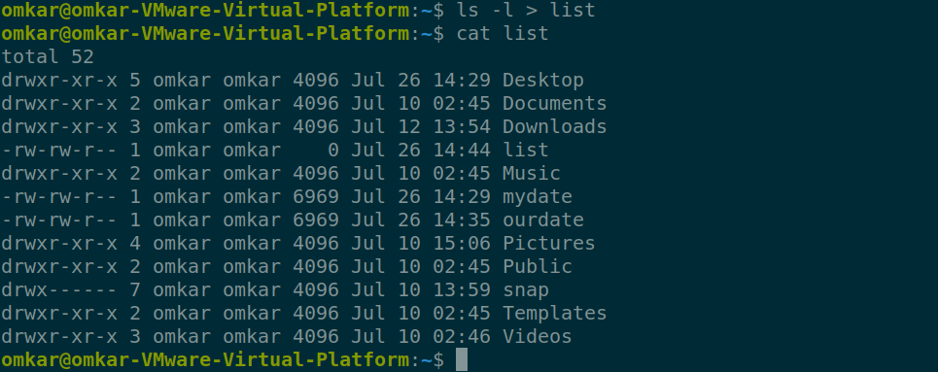

1. **Select any 5 capitals of states in India and enter them in a file named *capitals1*. Choose 5 more capitals and enter them in a file named *capitals2*. Choose 5 more capitals and enter them in a file named *capitals3*. Concatenate all 3 files and redirect the output to a file named *capitals*.**

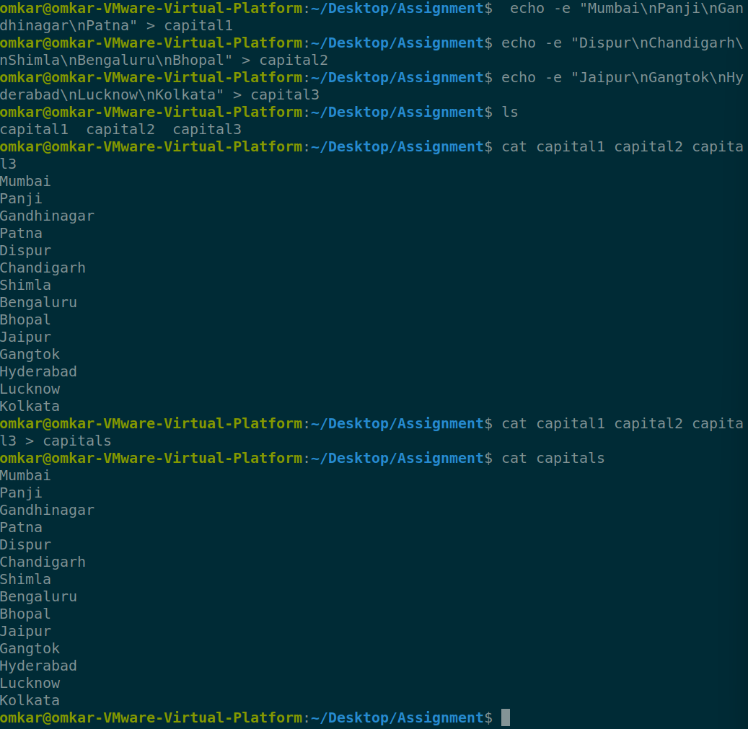

1. **Concatenate the file *capitals2* at the end of file *capitals*.**

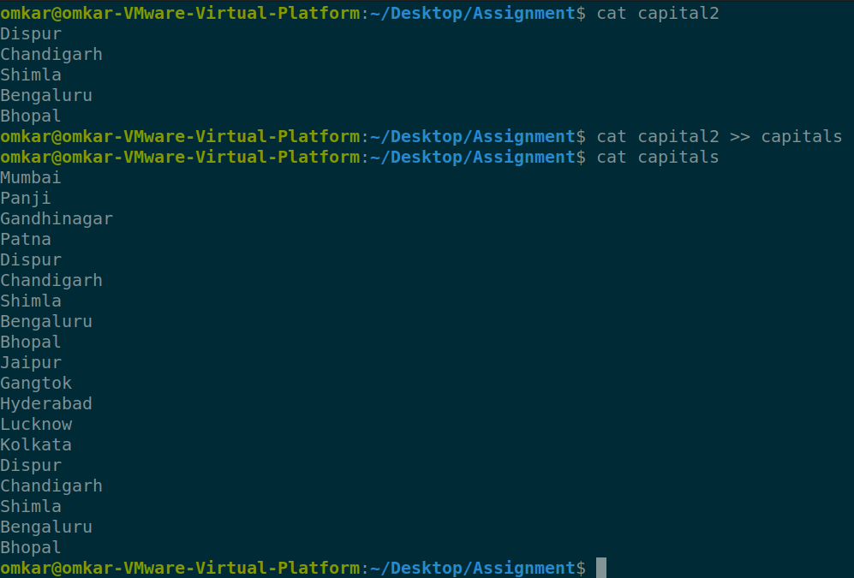

1. **Redirect the file *capitals* as an input to the command “wc –l”.**



1. **Give read and write permissions to all users for the file *capitals*.**

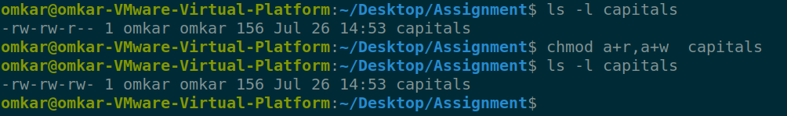

1. **Give read permissions only to the owner of the file *capitals*. Open the file, make some changes and try to save it. What happens ?**

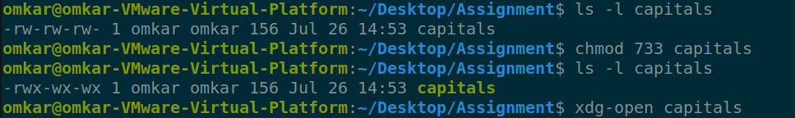

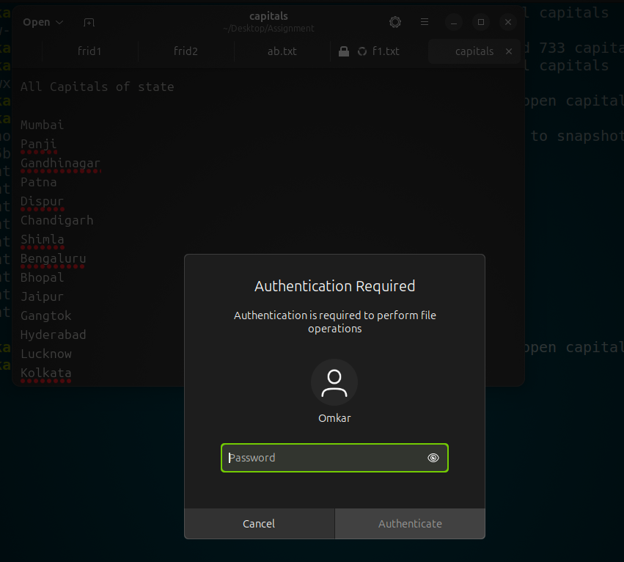

**Asking about the user password for authentication of owner**

1. **Create an alias to concatenate the 3 files *capitals1*, *capitals2*, *capitals3* and redirect the output to a file named *capitals*. Activate the alias and make it run.**

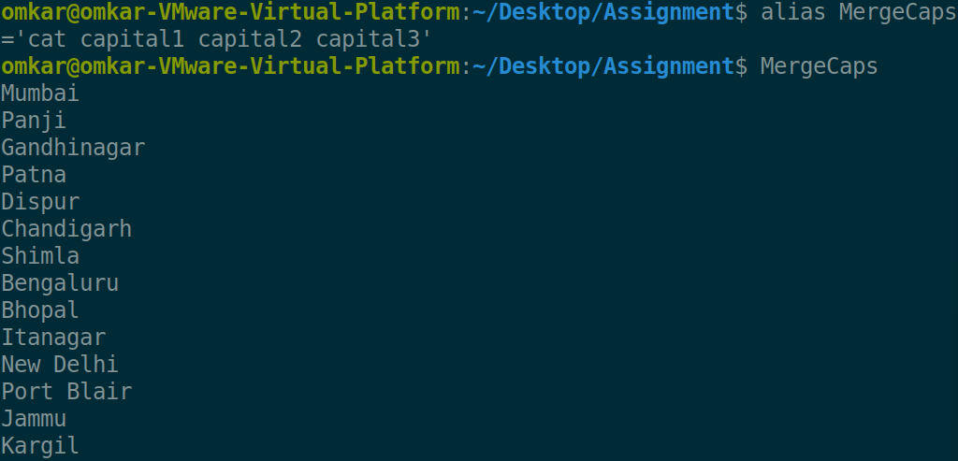

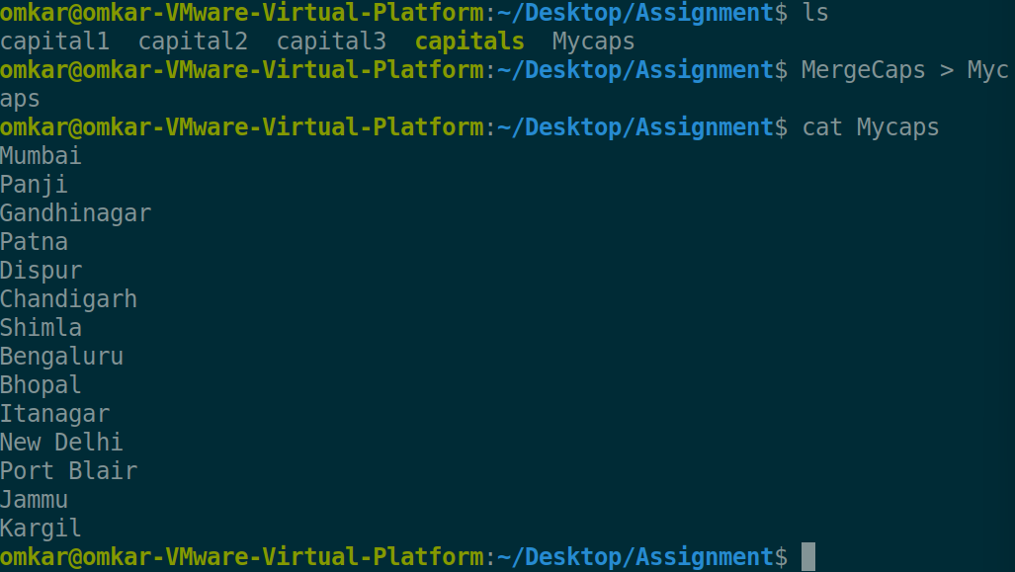

1. **What are the environment variables PATH, HOME and TERM set to on your terminal ?**

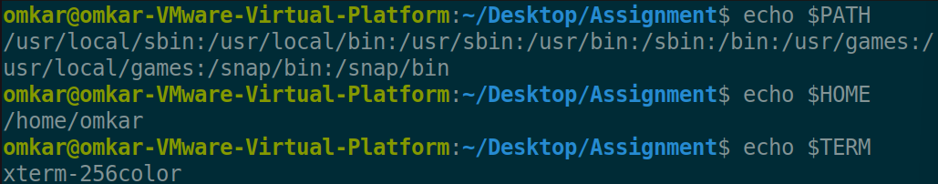

1. **Find out the number of times the string “the” appears in the file *mydate*.**



1. **Find out the line numbers on which the string “date” exists in *mydate*.**
2. **Print all lines of *mydate* except those that have the letter “i” in them.**
3. **Create the file *monotonic* as follows:**

**^a?b?b?c?…………..x?y?z$**

**Run the egrep command for *monotonic* against /usr/dict/words and search for all 4 letter words.**

1. **List 5 states in north east India in a file *mystates*. List their corresponding capitals in a file *mycapitals*. Use the *paste* command to join the 2 files.**
2. **Use the *cut* command to print the 1st and 3rd columns of the /etc/passwd file for all students in this class.**
3. **Count the number of people logged in and also trap the users in a file using the *tee* command.**